
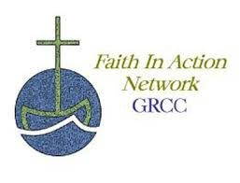


Community Memorial Service

for Our Neighbors Who Have Died Over the Past Years Without
Family or Resources

Sunday, February 19, 2023 at 2:00 pm
Peace of Christ at St. Ambrose Church 25 Empire Boulevard
Rochester, NY 14609
Corner of Empire, Culver and Clifford

All are welcome.

Sponsored by GRCC—Faith in Action Network For more information:
(585)254-2570 grcc1@frontiernet.net
GRCC—Faith in Action Network has organized a number of pastoral leaders to preside and attendees to be present for burial services for people who have died without family or resources. We will be celebrat- ing this Annual Memorial Service for people we have accompanied these past years. We have not celebrated since 2020 because of COVID is past year. Please share this invitation widely..

